Aircraft Velocity Removal for the ELDORA radar

7/31/08

This document describes the removal of aircraft velocity from the ELDORA radar data. This correction is only to be applied when operating in staggered PRT mode and only for data displayed in PPI. Data to be archived is NOT to be corrected for aircraft velocity. The procedure is as follows:
- Compute the ground relative airspeed.
- Compute the ground relative airspeed that effects the radar for fore and aft.
- Correct the measured velocity and place in appropriate nyquist interval.

Ground Relative Airspeed:

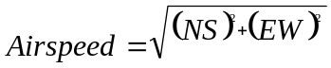, where NS is the north-south velocity and EW is the east-west velocity measured by the INS.

If Airspeed is less than 70 m/s or greater than 200 m/s or is Nan, then set Airspeed equal to 130 m/s.

Radar Effected Airspeed:

, where n is either the fore or aft radar and E_plane_angle is available from the header.

Corrected Velocity:
This assumes that the velocity convention used is negative velocities are approaching the radar.

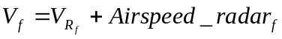
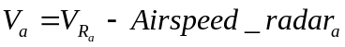

if (V_{n} > V_{nyquist})
V_{n} -= 2*V_{nyquist}
else if (V_{n} < V_{nyquist})
V_{n} += 2*V_{nyquist}

, where 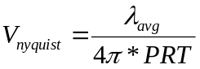 and n is either the fore or aft radar.

